**Ex.No 24**

**Database Design using ER modeling, normalization and Implementation for any application**

**Aim:**

To design a database using ER modeling and Normalization for student portal and sports meet Application

**Problem Statement: ER Diagram**

* A College is conducting a sports meet.
* Teams from recognized colleges are allowed.
* A team should have the players of same college.
* A player can play for more than one team.
* Events occurs in various grounds in the college.
* Winning teams receive awards.
* A captain is a player of a team.
* A player is a student of a college.
* Many teams can play a game.
* A game takes place in a ground.
* A college can have many teams.
* Only first two teams are awarded.

**IDENTIFICATION OF ENTITY:**

* COLLEGE
* PLAYERS
* TEAMS
* GAMES
* GROUND
* AWARDS

**DESCRIPTION ABOUT ENTITY:**

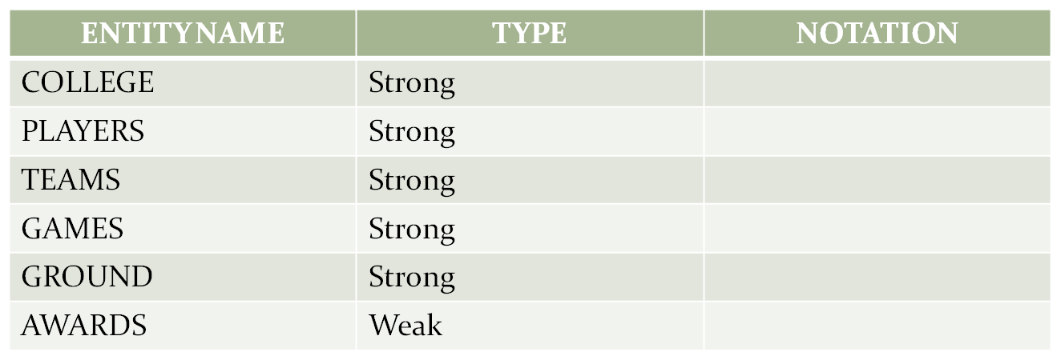

**ATTRIBUTES:**

* COLLEGE – CID, Name, Address line1, Address line2
* PLAYERS – FN, LN, POS, DOB, GENDER, PID
* TEAM - TID, Name, NOP, Rank, Team
* GAMES - GID, Name
* GROUND - ID, Name, Area
* AWARDS – Name, Position, Prize, Team

**DESCRIPTION ABOUT ATTRIBUTES:**

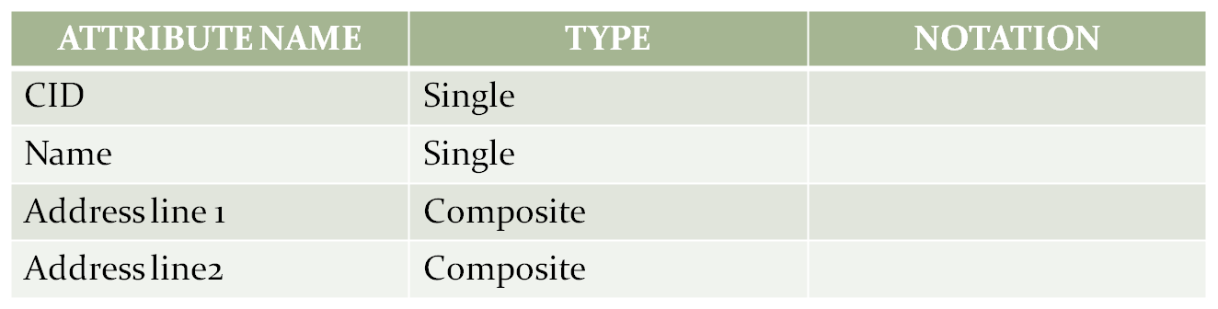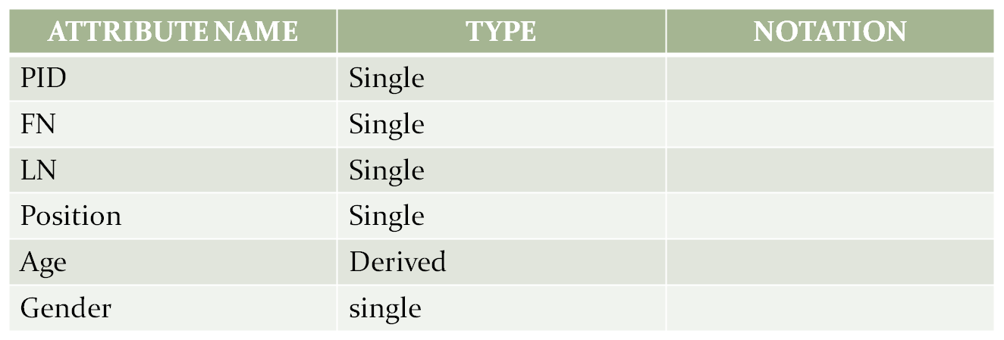

COLLEGE

PLAYERS

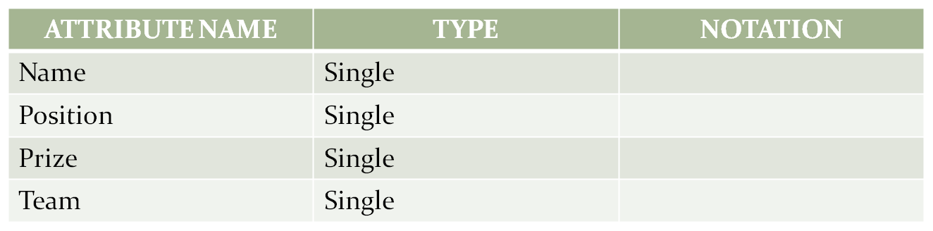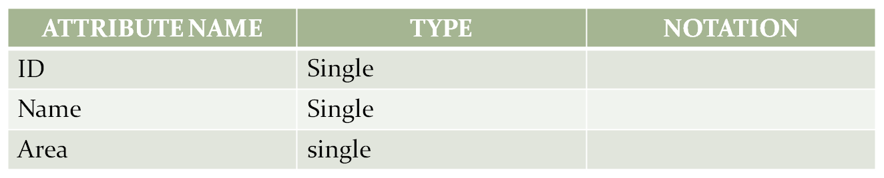

AWARDS

GROUND

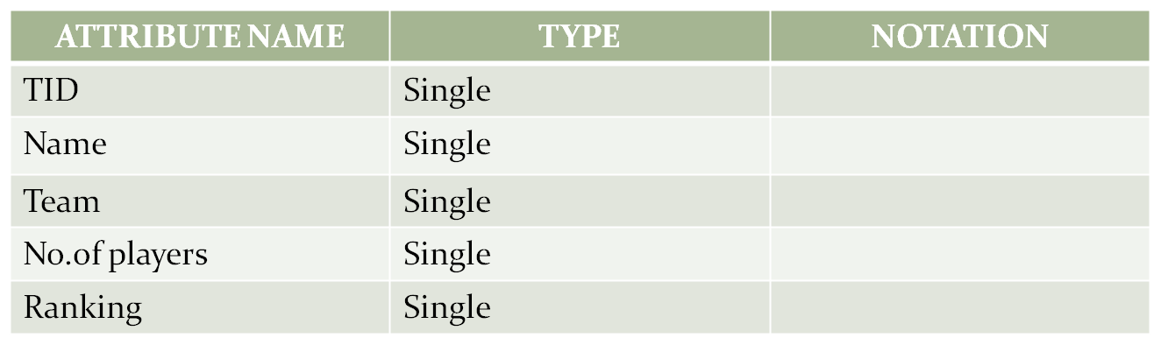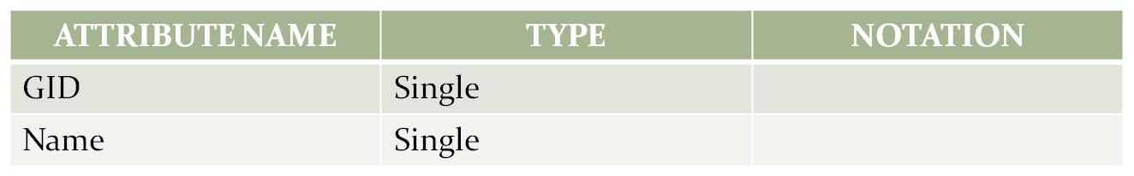

TEAMS

GAMES

**RELATIONSHIP:**

BINARY:

* + Plays
  + Has
  + Student of
  + Receives
  + Takes place

**ATTRIBUTES IN THE RELATIONSHIP:**

* Student of – CID, PID
* Has – TID, CID
* Plays – TID, GID
* Takes place – GID, ID
* Receives – TID, Position

**CARDINALITY AND RELATIONSHIP:**

* ONE TO ONE:Plays, Takes place
* MANY TO ONE:Student of
* ONE TO MANY:has

**CARDINALITY ABOUT RELATIONSHIP:**

* PLAYERS STUDENT OF COLLEGE.
* MANY TEAMS PLAY A GAME.
* A GAME TAKES PLACE IN A GROUND.
* A COLLEGE HAS MANY TEAMS.

**ER DIAGRAM:**

COLLEGE

PLAYERS

GAMES

TEAMS

GROUND

TAKES PLACE

HAS

STUDENT OF

PLAYS

RECEIVES

AWARDS

1

1

1

1

1

N

N

1

CAPTAIN

N

1

**Problem Statement: Normalization**

Createacollegedatabasethatcontainsstudentid,studentname,studentcity,dateofbirth,course id, course name, duration of the course, marks and grade and their relationships. The requirements are listedbelow:

* A college can offer one or morecourses.
* A student can enroll in one or morecourses.
* Courses can be taken by one or morestudents.
* A student can have student_id, student_name, date _of _birth andstudent_city.
* A student belongs to onecity.
* A city can have one or morestudents.
* A course can have course_id, course_name andduration.
* When a student finishes the course, a grade and marks areawarded.
* Grades are calculated based on themarks

Below 45 – U, 45-50 – E, 50-60– D, 60-70 – C, 70-80 – B, 80-90 – A, 90-100 –S

### FIRST NORMAL FORM

A relation is said to be in first normal form if and only if

*All the attributes in the relation must be atomic in nature.

*No multivalued and composite attributes in the table

### In a given table there is no multivalued and composite attributes, so it is satisfying normal form1

**SECOND NORMAL FORM**

A relation is said to be in second normal form if and only if

*It is in the first normal form and

\***No partial dependencies** exist between non-key attributes and key attributes.

|  |  |  |  |  |  |  |  |  |
| --- | --- | --- | --- | --- | --- | --- | --- | --- |
| **STUDENT ID** | **STUDENT NAME** | **STUDENT CITY** | **DOB** | **COURSE ID** | **COURSE NAME** | **DURATION** | **MARKS** | **GRADE** |

**From Requirements: (studentid, courseid is Composite Primarykey)**



**studentid**,courseid studentname

**studentid**,courseid studentcity

**studentid**,courseid dob PartialFunctional dependencies.

studentid,**courseid** coursename

studentid,**courseid** duration

studentid,courseid marks

**studentid,coursed** grade Full Functionaldependencies

### After removing partial functional dependencies from above table

**STUDENT**

|  |  |  |  |
| --- | --- | --- | --- |
| **STUDENTID** | **STUDENTNAME** | **STUDENTCITY** | **DOB** |

**COURSE**

|  |  |  |
| --- | --- | --- |
| **COURSEID** | **COURSENAME** | **DURATION** |

**RESULT**

|  |  |  |  |
| --- | --- | --- | --- |
| **STUDENTID** | **COURSEID** | **MARKS** | **GRADE** |

**THIRD NORMAL FORM**

A relation is said to be in the third normal form if and only if

*it is in Second Normal Form

\***No transitive dependency** exists between non-key attributes and key attribute



**studentid,coursed** marks

**marks** grade Transitivedependency

**studentid,courseid** grade

After removing transitive dependency from above table

**STUDENT**

|  |  |  |  |
| --- | --- | --- | --- |
| **STUDENTID** | **STUDENTNAME** | **STUDENTCITY** | **DOB** |

**COURSE**

|  |  |  |
| --- | --- | --- |
| **COURSEID** | **COURSENAME** | **DURATION** |

**MARKS**

|  |  |  |
| --- | --- | --- |
| **MARKID** | **RANGE1** | **RANGE2** |

**RESULT**

|  |  |  |
| --- | --- | --- |
| **STUDENTID** | **COURSEID** | **MARKID** |

**Result:**

**Thus the database is designed and normalized.**